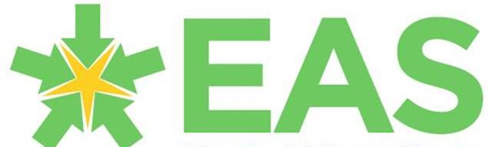

AS Level History

A Guide to help you get ready to study A Level History



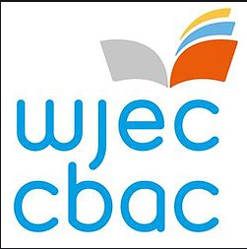
Don’t forget your GCSE!

If you studied GCSE History, it is likely that the topics or periods in History you studied will not be the same as the AS level topics. But the skills of enquiry, interpretation, analysis, evaluation, and synthesis that yu developed at GCSE will be needed at A Level. So, it is important to keep the History skills and ways of working as an historian fresh in your mind ready to start your A levels in September.
Why not spend some time looking over your GCSE notes, and consider:
How did you use and evaluate sources as an Historian?
How did you evaluate the validity of different interpretations?
How did Historians analyse and explain causation, consequence, significance, continuity and change?

If you did not study GCSE History, have a look at these articles to get you thinking about the understanding and skills you will need to develop:
https://www.open.edu/openlearn/history-the-arts/history/what-history
https://www.open.edu/openlearn/history-the-arts/history/what-history-being-historian?in_menu=1051263

What is the AS level course?
There are a lot of choices of topics in the AS level course. Find out which topics have been chosen by your school/college to study in Year 12.
AS Level
Unit 1 – Period Study.  The period study is a topic covering around 100 years. The period study focuses on continuity and change over a substantial period of time.  The examination is extended writing, essay style questions. | Topic options for Unit 1 (you will study 1):  1. Government, rebellion and society in Wales and England c.1485- 1603  2. Government, revolution and society in Wales and England c.1603- 1715  3. Politics, protest and reform in Wales and England c.1780-1880  4. Politics, people and progress in Wales and England c.1880-1980  5. Political and religious change in Europe c.1500-1598  6. Europe in the age of absolutism and revolution c.1682-1815  7. Revolution and new ideas in Europe c.1780-1881  8. Europe in an age of conflict and co-operation c.1890-1991
Unit 2 – Depth Study (Part 1)  A shorter period is studied in depth for unit 2 and is continued in Unit 4 at A level in year 13. In Unit 2, the focus is on using and analysing historical evidence and considering a range of interpretations of events.  The unit 2 examination has a range of sources with open ended questions. | Topic options for unit 2 (you will study 1):  1. The mid Tudor crisis in Wales and England c.1529-1570. Part 1: problems, threats and challenges c.1529-1553  2. Royalty, rebellion and republic c.1625-1660. Part 1: the pressure on the monarchy and the drift to civil war, c.1625-1642  3. Reform and protest in Wales and England c.1783-1848. Part 1: radicalism and the fight for parliamentary reform, c.1783-1832  4. Politics and society in Wales and England c.1900-1939. Part 1: politics, society and the war: Wales and England c.1900 -1918

Finding out more about the course…
The following documents are designed for teachers, but some sections will be of use to you to help you to find out more about the course.
WJEC GCE Specification | https://www.wjec.co.uk/media/uwlondvv/wjec-gce-history-spec-from-2015-e.pdf | Page 2 outlines the AS and A Level course. If you know the topics chosen by your school/college, you could read about each one from pages 18 onwards.
WJEC Past papers and marking schemes | https://www.wjec.co.uk/en/qualifications/history-as-a-level/#tab_pastpapers | Have a look at what the examination papers look like for AS level – choose the papers for the topics your school/college covers. See how the examination papers are marked in the marking schemes.

Book and Magazine Recommendations

Depending on which periods you are studying for the AS course, your teachers will direct you to specific set books that you will use during your course. But, to do well in History, wide reading is important.
The Historical association has put together a list of suggested reading for a range of topic areas: https://www.history.org.uk/student/resource/3213/reading-at-a-level
Other suggested things to read:
History today magazine. Available online or in the shops. A range of articles about different historical periods and topics.  https://www.historytoday.com/ | 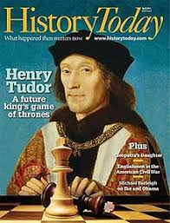
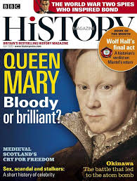 | BBC History magazine. Great selection of articles on a range of themes. BBC also makes a BBC world Histories and a BBC Histories revealed magazine. https://www.historyextra.com/
The Seminar studies books are a series of small books focused on specific areas of the AS and A Level course. This is a good series to look at once you know the specific topics you will be studying. | 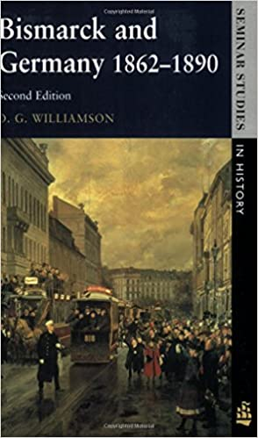
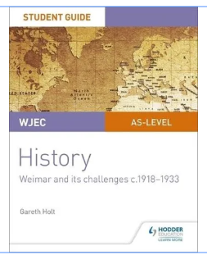 | WJEC produced student guides are available to purchase from various websites. Look for the specific topics you will be covering.

Movie and TV Recommendations
Again, depending on your AS level topic choices, there are likely to be some films that your teachers will recommend. These ideas below should appeal to historians regardless of what topic you ae studying.

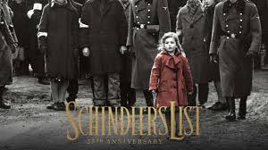 | 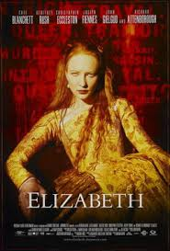
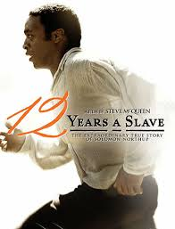 | 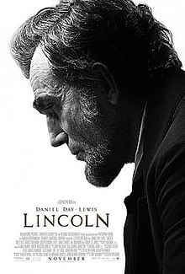
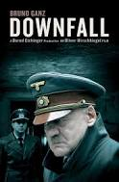 | 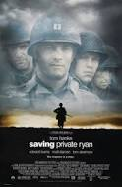

There are lots of really good History documentaries, many available on demand. Try Simon Sharma’s ‘History of Britain’ or Lucy Worsley’s ‘Six Wives’.

Website Recommendations

Historical Association. Resources are free once you are registered. Some resources require a student membership fee. The site has topic guides, notes and reading lists for a range of topics. | https://www.history.org.uk/student/categories/16-18
WJEC resources  Lots of information about each of the units you will study. There are lesson activities for you to work through for each unit. | https://resources.wjec.co.uk/Pages/ResourceByArgs.aspx?subId=17&lvlId=1


Social Media

Suggestions of people to follow on Twitter:
@EAS_Humanities Our EAS twitter account for al things Humanities, including History!

@histassoc Historical Association twitter account

@RoyalHistSoc Royal Historical Society twitter account

@thehistoryguy Dan Snow

@HISTORY

Also, look up the academics from your local university – follow them as well.

Getting ready to study…..

Have a go at the following activities to help you to get ready for your AS level course:

Task 1 – practice your skills of analysing Historical sources.
Read the guidance on analysing sources here:
https://www.history.org.uk/student/categories/916/resource/3211/using-historical-sources
Choose a source from the past paper for the depth study you are going to study: https://www.wjec.co.uk/en/qualifications/history-as-a-level#tab_pastpapers
For the source you choose, make notes about each aspect of source evaluation. You could stick the source on an A3 sheet and make your notes around it.
The first link also has examples of cartoons to analyse – complete those activities as well.

Task 2 - Practice your note making skills
Making notes from what you read and from your lessons is a very useful skill to have. Writing notes helps you to process and remember the key facts. The notes are then ready for revision.
Read the guidance here on making notes: https://www.history.org.uk/student/categories/916/resource/3208/taking-notes-at-a-level-history
Search on Youtube for videos about good ways of making notes.
Practise – Choose an article from one of the BBC History magazines: https://www.historyextra.com/ or from a relevant book or magazine, and practise making notes in a clear and concise way.

