AS Level PE

A Guide to help you get ready to study AS Level PE



Introduction
The contents and resources suggested in this document are provided by Newport High School, Newport. We would like to thank colleagues at the school for their generous offer of support and sharing practice to create this document
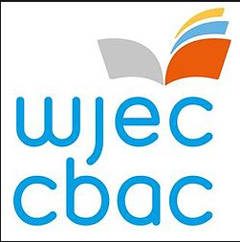

Don’t forget your GCSE and
Introduction to the AS and A ‘level

If you studied GCSE PE, here are some resources to support you with revision on topics plus introduce you to the AS and A level
Course Specification: https://www.wjec.co.uk/media/zpzffdr4/wjec-gce-physical-education-spec-from-2016.pdf

Suggested websites:
WJEC has many online resources found on their main web page, but the following link will give you the most updated resources for AS PE:
https://resources.wjec.co.uk/Pages/ResourceSingle.aspx?rIid=2240

Mr Wnuk PE a wide range of resources, quizzes and webinars covering GCSE and AS/A level
https://sites.google.com/view/mrwnukpe/home

James Morris on Youtube – a series of Playlist of different topics relevant to the AS level PE
https://www.youtube.com/channel/UCChU8cYZY5xpQ7pBIklu3Xw

Sport Psychology - provides an insight around the mental skills needed to reach peak performance and excel in sports.
http://sportpsychologytoday.com/

Suggested Books
There is no specific A level PE book by WJEC but here are some useful resources you may want to purchase or look at:
AS Physical Education - Anatomy
http://resource.download.wjec.co.uk.s3.amazonaws.com/vtc/2015-16/15-16_30/eng/index.html

Individual AS Unit resources – Theory, Examples and exam questions
https://resources.wjec.co.uk/Pages/ResourceSingle.aspx?rIid=660

Suggested Viewing
TED talks are highly recommended. Have a browse through the many TED talks available; the main topics that you may discover here are: Personality, Stress Arousal and anxiety, Motivation and self-efficacy.
Inside the mind of champion athletes
https://www.youtube.com/watch?v=yG7v4y_xwzQ

Win the game of life https://www.ted.com/talks/jonathan_fader_win_the_game_of_life_with_sport_psychology

https://blog.ted.com/5-great-ted-talks-for-athletes/

Are athletes really getting faster, better, stronger - David Epstein explains
https://www.ted.com/speakers/david_epstein

The following page has some suggested films to watch which are relative to a wide range of aspects associated with Sport both physical and mental.

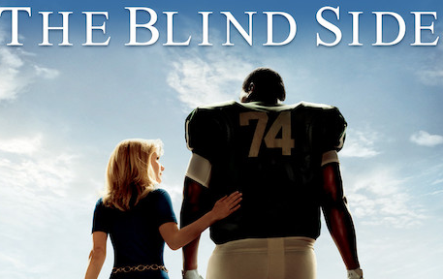
Films


The Blind Side (2009)

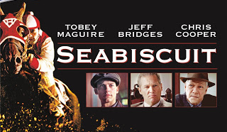
Seabiscuit (2003)
Cool Runnings
(1993)


Field of Dreams (1989)


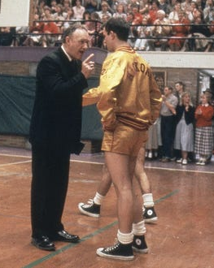
Hoosiers (1986)

Kicking and

Screaming
(1995 and 2005)

Remember the Titans (2000)

