AS Level Sociology

A guide to help you prepare yourself for studying AS Level Sociology



The contents and resources suggested in this document are provided by Bassaleg School, Newport. We would like to thank colleagues at the school for their generous offer of support and sharing practice in the creation of this document.

Making notes

Research, reading and note making are essential skills for A Level Sociology study. ‘Cornell Notes’ is one method you may want to use for the following tasks.

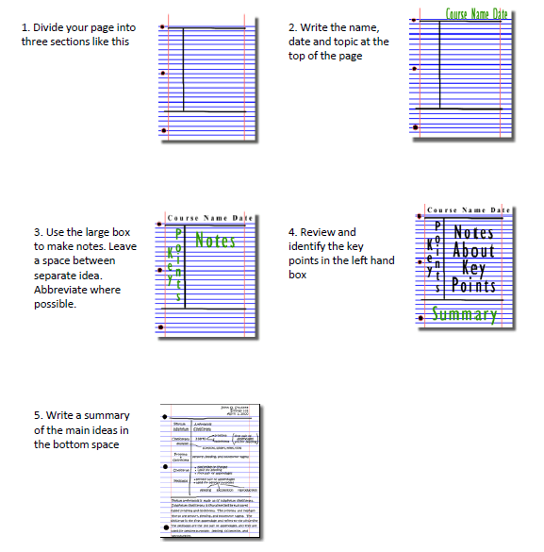
Images taken from http://coe.jmu.edu/learningtoolbox/cornellnotes.html
You could also produce mind maps. This is a more visual means of representing information.
1. Identify the main subject or topic and write this in the centre of the page.
2. As major facts are presented create subheadings with appropriate facts coming off.
3. Once you have created your visual representation, use the space around the edge of the paper to make a note of any questions you may have.

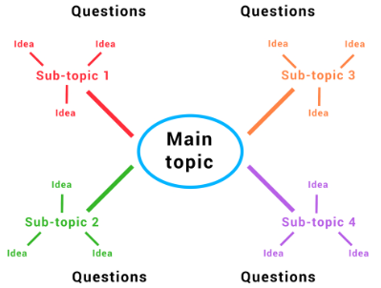

Images taken from: https://www.oxbridgeessays.com/blog/master-lecture-notes-tips-really-work/#notestyles

Documentary Recommendations
Here are some documentaries that you may find of interest….

National Geographic  Feral Children  A jungle boy raised by monkeys. Twin girls nurtured by wolves. What does this tell us about the importance of learning? Did these children ever manage to live ‘normally’? | 
 | Three Identical Strangers  In 1980 New York, three young men who were all adopted meet each other and find out they’re triplets who were separated at birth. Focus on their behaviour. Is it a result of how they were raised, or is it genetic?
An Idiot Abroad  Karl Pilkington has no interest in global travel. Ricky Gervais and Stephen Merchant make him travel while they stay in the UK and monitor his progress. Consider the similarities and differences between the British culture and the culture viewed. | 
 | Three wives, one husband.  Filmmakers gain access to the community of Rockland Ranch in the middle of the Utah desert where 14 polygamous Mormon families have created unique homes for themselves. Consider the positive and negative aspects of living in a polygamous family.
School Swap: Korea Style  Welsh teenagers from Pembrokeshire experience South Korea’s education systems, one of the best and toughest, in the world. Think about the similarities and differences between the British education system and the Korean education system. | 

Murder to Mercy  The Cyntoia Brown Story  Cyntoia was arrested as a child, tried as an adult and sentenced to life. This particular documentary shows how crime is a social construct and can change over time. As the law changes, does she deserve to serve a life sentence? | 
 | The Innocence Files  Wrongfuly convicted of horrible crimes, these individuals lost everything. This documentary shows how the criminal justice system can sometimes make mistakes. After watching each episode think about whether there is a typical offender that the police target.
Inside the worlds toughest prisons  Raphael Rowe, who spent 12 years behind bars for a crime he didn’t commit, investigates some of the world’s toughest prisons from the inside. Is there a link between poverty and criminal behaviour? Do you think that reoffending is lower the tougher the prison? | 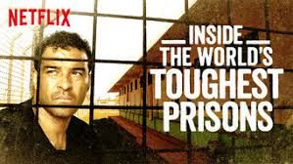
 | Why do men earn more than women?  Karren Brady is on a mission to find out why women earn less than men. Think about the changes that could be implemented to improve the gender pay gap in Britain. What are other countires doing to close the gap?
Rich house, Poor house.  Two families from opposite ends of the wealth divide swap homes, budgets and lives for seven days to find out whether money really does buy happiness. Think about whether money really matters. Does money make you happy? | 
Getting ready to study…..
Sociology focuses on familiar aspects of life such as Family, Education, Crime and Inequality. They are examined from traditional and more contemporary theoretical perspectives. Complete the following tasks to gain some background knowledge so you are ready to start studying.
Conjugal Relationships

Young and Willmott claimed that the traditional segregated division of labour in the home - men as the breadwinners and females as the housewives - was breaking down. They argued that roles, responsibilities and relationships within the family have changed in recent years because there has been a long term trend towards joint conjugal roles where all domestic tasks, childcare and decision making are shared equally between men and women. They called this type of family the ‘symmetrical family’

This particular task will prepare you for the sociological debate in Unit 1 which explores whether conjugal roles are symmetrical or segregated.

Read the information on these websites (you could make more Cornell notes or a mind map if you wish):
Are conjugal roles changing PowerPoint
https://resources.wjec.co.uk/Pages/ResourceSingle.aspx?rIid=643
https://www.s-cool.co.uk/a-level/sociology/conjugal-relationships/revise-it/conjugal-relationships-1

And take a look at these videos:
https://www.youtube.com/watch?v=MWq50UDgqgY
https://www.youtube.com/watch?v=pc8h1R9D5jw

Task: Produce a one-page revision guide summarising conjugal relationships.
Your revision guide should include:
- Key words and definitions
- Evidence to support that conjugal roles are becoming equal.
- Evidence to support that conjugal roles remain unequal.
- Short explanations of why conjugal roles may be changing.

Differential Attainment

Since the introduction of compulsory state education, the educational level of the average UK citizen has dramatically improved. However, at all stages of education – primary, secondary, further and higher – there is differential educational achievement. Some sociologists blame factors external to the school. However, other sociologists blame internal factors, especially teachers and the organisation of schools.

This particular task will prepare you for the sociological debate in Unit 2 which explores multiple explanations for differential attainment between students.

Read the information on these websites (you could make more Cornell notes or a mind map if you wish):
https://www.s-cool.co.uk/a-level/sociology/inequalities/revise-it/class
https://www.s-cool.co.uk/a-level/sociology/inequalities/revise-it/gender
https://www.s-cool.co.uk/a-level/sociology/inequalities/revise-it/ethnicity

And take a look at these videos:
https://www.youtube.com/watch?v=p_nKvHHeohU&list=PLEnZEZyk_0sqZmp8DIdoQ8OWO8NvAiD6W&index=2
https://www.youtube.com/watch?v=8jnSC7Yuuu4&list=PLEnZEZyk_0sqZmp8DIdoQ8OWO8NvAiD6W&index=4&disable_polymer=true
https://www.youtube.com/watch?v=9-dp9MjMhwQ&list=PLEnZEZyk_0sqZmp8DIdoQ8OWO8NvAiD6W&index=7

Task:
Produce a one-page revision guide summarising one of the following topics: Gender and attainment, Ethnicity and attainment, or Social Class and attainment.

Whichever topic you choose, your revision guide should include:
- An overview of the relationship. You should include statistics or graphs to support.
- Possible explanations for the relationship.
- Sociological evidence to support each explanation.

Criminal Statistics

Many theories of crime are based on the official statistics provided by the government organisations such as the police and courts. This information is often taken as an accurate measure of the total amount of crime. The data allows comparisons to be made between crimes, and with previous years.

This particular task will prepare you for the sociological debate in Unit 3 which explores whether crime statistics are an accurate measure of criminal behaviour.

Read and make notes on the information on these websites (you could make more Cornell notes or a mind map if you wish):
https://www.s-cool.co.uk/a-level/sociology/crime-and-the-effects-of-crime/revise-it/crime statistics
Measuring crime PowerPoint
https://resources.wjec.co.uk/Pages/ResourceSingle.aspx?rIid=647

And take a look at these videos:
https://www.youtube.com/watch?v=jzdTiM5wS_c

Task:
Using the website https://www.police.uk/, create a poster to explore the criminal statistics in your area. Your work should compare crime statistics in your area with a location you believe crime rates are high. Are there similarities in the types of crimes being committed? Are the crimes completely different? You could use a Venn diagram to do this.

Your poster should:
- Describe what official statistics are.
- Compare and contrast your area with another location
- Explain why the official statistics may not be an accurate measure of criminal behaviour.

Social Inequality

Gender is considered to be a major source of inequality both in the contemporary UK and globally. In the public sphere of work and social life and in the private sphere of family life and relationships, males and females often encounter different experiences. Gender inequalities can be seen in a range of different areas.

This particular task will prepare you for evidence question in Unit 4 which involves identifying sociological evidence to suggest that certain groups experience inequality within the contemporary society.

Read the information on these websites (you could make more Cornell notes or a mind map if you wish):
Women and work PowerPoint
https://resources.wjec.co.uk/Pages/ResourceSingle.aspx?rIid=645
https://www.theguardian.com/world/2019/apr/04/gender-pay-gap-figures-show-eight-in-10-uk-firms-pay-men-more-than-women
https://www.s-cool.co.uk/a-level/sociology/domestic-violence/revise-it/violence
https://www.s-cool.co.uk/a-level/sociology/poverty/revise-it/measuring-poverty

And take a look at these videos:
https://youtu.be/4viXOGvvu0Y
https://youtu.be/it0EYBBl5LI

Task:
Produce a one-page revision guide summarising one area of life where females experience inequality. You could focus on;
- Family – Domestic violence, domestic labour etc.
- Work – Gender pay gap, promotion opportunities etc.
- Health – mortality rates, chronic illness etc.

Whichever topic you choose, your revision guide should include:
- An overview of the inequality. You should include statistics or graphs to support.
- Possible explanations for the inequality.
- Sociological evidence to support each explanation.

Analysing Data…..
One of the skills needed in Unit 2 involves interpreting Sociological data. You may already have experience of this as you would have analysed data when completing your individual project during the Welsh Baccalaureate. The following section provides an opportunity for you to practise this skill.
Education

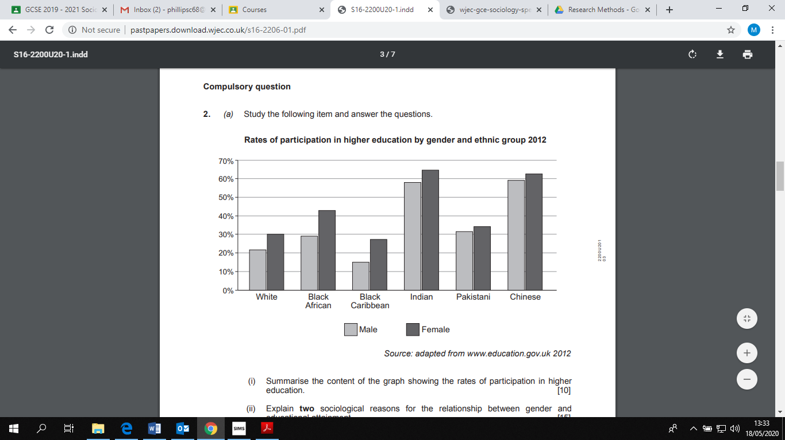

Task: Identify five patterns from the data above. You will need to use statistics from the source to support the pattern.

You may want to consider;
- Patterns of participation of different ethnic groups.
  - Consider the ethnic group with the highest participation.
  - Consider the ethnic group with the lowest participation.
  - Which two groups have the smallest participation difference?
  - Which two groups have the biggest participation difference?
- Patterns of participation related to gender.
  - Identify the gender with the highest participation.
  - Identify the gender with the lowest participation.

Religion

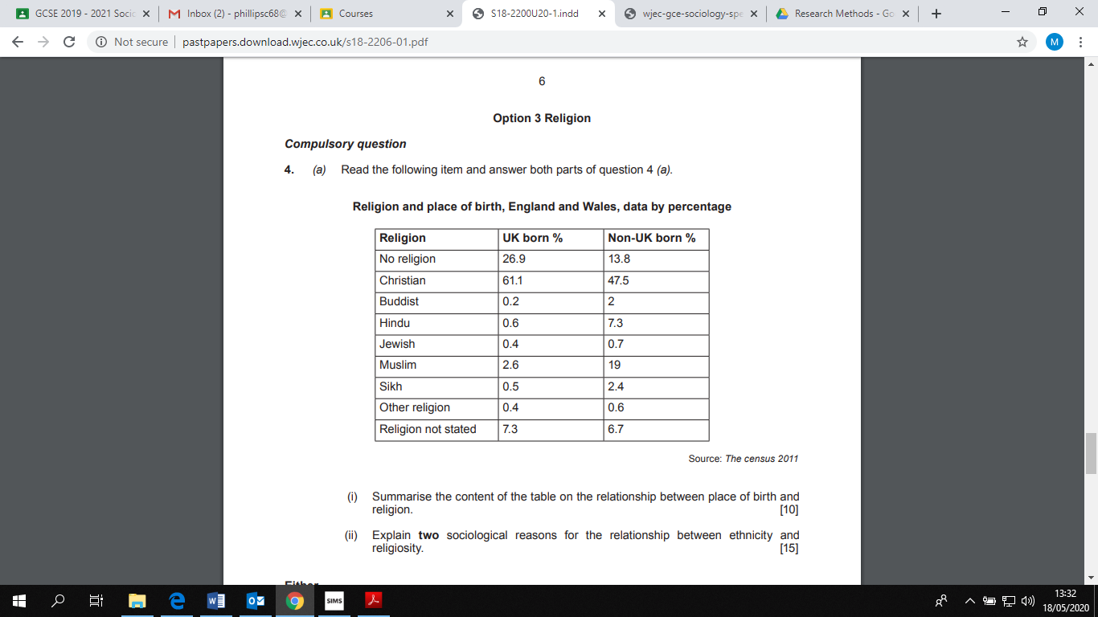
Task: Identify five patterns from the data above. You will need to use statistics from the source to support the pattern.

You may want to consider;
- The relationship between place of birth and whether an individual identified with a religion.
  - Identify the religion with the highest and lowest percentage of UK born followers.
  - Identify the religion with the highest and lowest percentage of non-UK born followers.
  - Which religion has the biggest and smallest difference between UK born and non-UK born followers?

Media
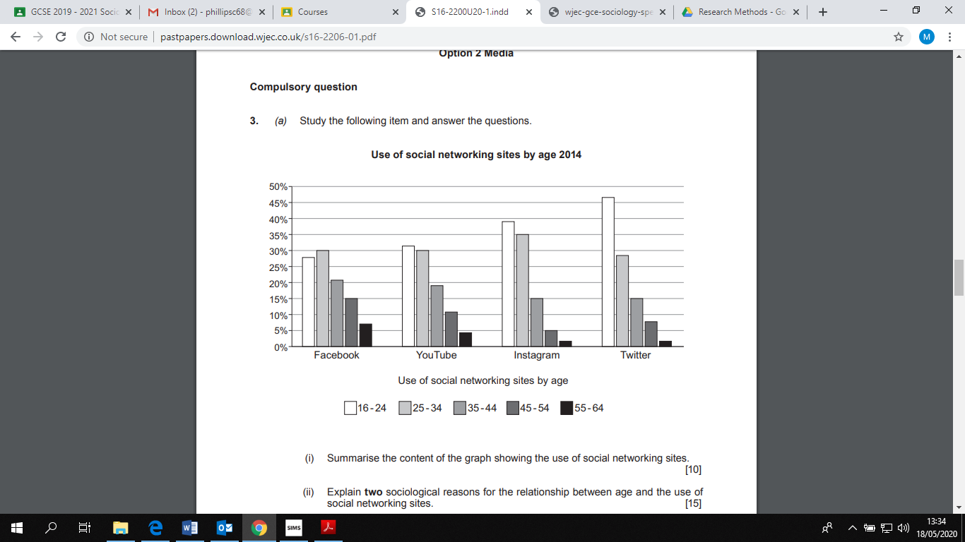

Task: Identify five patterns from the data above. You will need to use statistics from the source to support the pattern.

You may want to consider;
- Use of social networking related to age.
  - Consider the category which has the oldest age group.
  - Consider the category which has the youngest age group.
  - Are there any consistent trends related to age?
- The overall usage of social networking sites.
  - Identify the social network which has the highest use overall.
  - Identify the social network which has the lowest use overall.


Social Media

Suggestions of people to follow on Twitter:

- Sociology Support –Experienced senior examiners in Sociology sharing news, resources and assessment knowledge. @SociologySup

- Ken Browne – Sociology textbook author. Shares resources and news. @BrowneKen

- Sociology Journal – An official journal of the BSA. They publish outstanding and original research across all areas of Sociology. @sociologyjnl

- The Sociological Review –Publishing Sociological research for over 100 years. @TheSocReview

- All Sociology – Sociology visuals for students. Also links to Sociology podcasts. @allsociology

NB – Your school may also have their own Sociology twitter account.

Keeping it Fresh……..
It is important to keep the knowledge you have gained at GCSE fresh in your mind ready to start your A levels in September.

Why not spend some time looking over some past papers and using the mark schemes to assess how well you’ve done.
Component 1 & 2 – Past Papers and Marking Schemes:
https://www.eduqas.co.uk/qualifications/sociology-gcse/#tab_pastpapers

NB – You do not need to have studied GCSE Sociology in order to move on to A Level Sociology.

Planning Ahead…….
In order to prepare yourself for further study, have a look at the resources below:
WJEC Specification – GCE AS/A Level in Sociology | https://www.wjec.co.uk/media/owifffk1/wjec-gce-sociology-spec-from-2015.pdf
WJEC Specimen Assessment Materials | https://www.wjec.co.uk/media/1dto1glp/wjec-gce-as-a-level-sociology-sams-formatted.pdf
WJEC Past Papers and Marking Schemes | https://www.wjec.co.uk/qualifications/sociology-as-a-level/#tab_pastpapers
Unit 1 Resources | https://resources.wjec.co.uk/Pages/ResourceSingle.aspx?rIid=643  https://resources.wjec.co.uk/Pages/ResourceSingle.aspx?rIid=644  https://resources.wjec.co.uk/Pages/ResourceSingle.aspx?rIid=639
Unit 2 Resources | https://resources.wjec.co.uk/Pages/ResourceSingle.aspx?rIid=637  https://resources.wjec.co.uk/Pages/ResourceSingle.aspx?rIid=646  https://resources.wjec.co.uk/Pages/ResourceSingle.aspx?rIid=638  https://resources.wjec.co.uk/Pages/ResourceSingle.aspx?rIid=648
Unit 3 Resources | https://resources.wjec.co.uk/Pages/ResourceSingle.aspx?rIid=647  https://resources.wjec.co.uk/Pages/ResourceSingle.aspx?rIid=641  https://resources.wjec.co.uk/Pages/ResourceSingle.aspx?rIid=642  https://resources.wjec.co.uk/Pages/ResourceSingle.aspx?rIid=640
Unit 4 Resources | https://resources.wjec.co.uk/Pages/ResourceSingle.aspx?rIid=645

Career opportunities and progression …….
Sociology provides an excellent foundation for a wide variety of higher level courses and professions. Sociological modules are found on many undergraduate courses in subjects such as medicine, law, criminology, journalism, politics, environmental and earth science courses, social work, education, a wide range of health care professional courses and many more.
All universities recognise Sociology as an academic A Level. Sociology provides an understanding of the social processes that are part and parcel of any work role and as such enables students to apply their understanding across a wide range of careers.
Students of Sociology usually agree that “everyone should do it”. Sociology is an academic discipline which teaches skills required for lifelong learning.

