AS Level Physics

A guide to help you prepare yourself for studying AS Level Physics

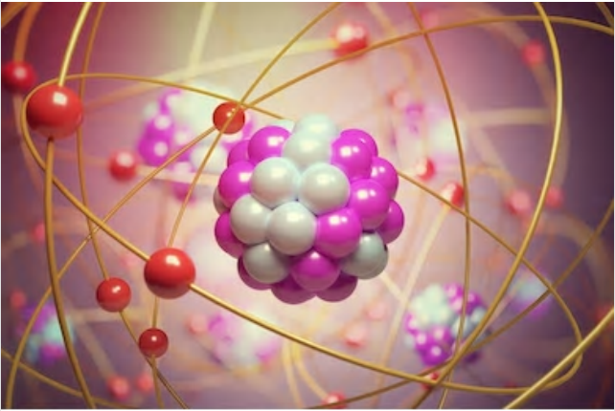

Questions you may be asking yourself as a physicist:

- Do heavy objects fall faster than lighter ones, and is it any different on the moon?
- If I get thrown out of a cannon can I figure out how high I will go and where I will land, and does it depend on my weight or my speed?
- How does the speed camera know how fast I am going, and the SatNav know where I am? And what safety features does my car have built in when I find myself in a jam?
- What makes Christmas tree lights flash on and off, and how can I make them brighter?
- How does a microwave do what it does, and why can I hear around corners?

Book Recommendations

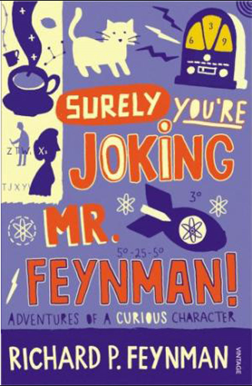 | Surely You're Joking Mr Feynman: Adventures of a Curious Character  Richard Feynman was a Nobel Prize winning Physicist. By reading this book, you will get insight into his life’s work including the creation of the first atomic bomb, his bongo playing adventures and his work in the field of particle physics.
Quantum Theory Cannot Hurt You: Understanding the Mind-Blowing Building Blocks of the Universe

Any Physics book by Marcus Chown is an excellent insight into some of the more exotic areas of Physics that require no prior knowledge. In your first year of A-Level study you will meet the quantum world for the first time. This book will fill you with interesting facts and handy analogies to whip out to impress your peers!
Moondust: In Search of the Men Who Fell to Earth

One of the greatest scientific achievements of all time was putting man on the surface of the moon. Only 12 men made the trip to the surface, at the time of writing the book only 9 are still with us. The book does an excellent job of using the personal accounts of the 9 remaining astronauts and many others involved in the space program at looking at the whole space-race era, with hopefully a new era of space flight about to begin as we push on to put mankind on Mars in the next couple of decades.
A Short History of Nearly Everything

A modern classic. Popular science writing at its best. A Short History of Nearly Everything Bill Bryson’s quest to find out everything that has happened from the Big Bang to the rise of civilization - how we got from there, being nothing at all, to here, being us. Hopefully by reading it you will gain an awe-inspiring feeling of how everything in the universe is connected by some fundamental laws.

Movie Recommendations

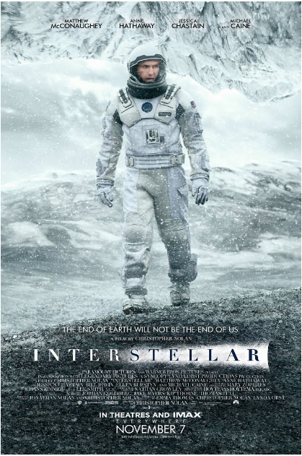 | Interstellar  In Earth's future, a global crop blight and second Dust Bowl are slowly rendering the planet uninhabitable. Professor Brand, a brilliant NASA physicist, is working on plans to save mankind by transporting Earth's population to a new home via a wormhole. But first, Brand must send former NASA pilot Cooper and a team of researchers through the wormhole and across the galaxy to find out which of three planets could be mankind's new home.
The Imitation Game  Alan Turing, a British mathematician, joins the cryptography team to decipher the German enigma code. With the help of his fellow mathematicians, he builds a machine to crack the codes. | 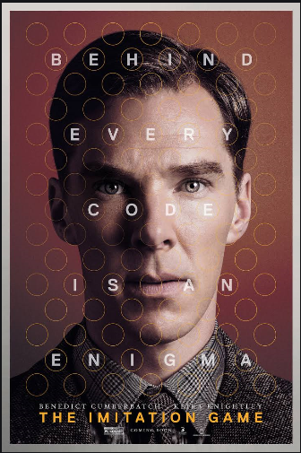
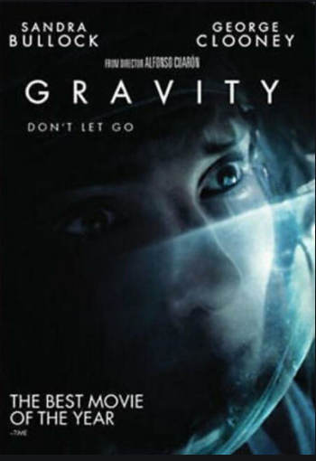 | Gravity  Gravity focuses on two astronauts as their Space Shuttle mission is torn apart (literally) by an orbiting field of space debris. The rest of the film focuses on their struggle to survive in the silent, zero-gravity, and zero-oxygen environment above earth.
The Martian  When astronauts blast off from the planet Mars, they leave behind Mark Watney presumed dead after a fierce storm. With only a meagre amount of supplies, the stranded visitor must utilize his knowledge of science, wits and spirit to find a way to survive on the hostile planet. Meanwhile, back on Earth, members of NASA and a team of international scientists work tirelessly to bring him home, while his crew mates hatch their own plan for a daring rescue mission. | 

Other on screen recommendations:

- Minute Physics – Variety of Physics questions explained simply in a couple of minutes.
- Wonders of the Universe / Wonders of the Solar System – Both available of Netflix– Brian Cox explains the Cosmos using some excellent analogies and wonderful imagery.
- Shock and Awe, The Story of Electricity – A 3 part BBC documentary that is essential viewing if you want to see how our lives have been transformed by the ideas of a few great scientists a little over 100 years ago.
- NASA TV – Online coverage of launches, missions, testing and the ISS. Plenty of clips and links to explore to find out more about applications of Physics in Space technology.
- The Fantastic Mr. Feynman –. See the life’s work of the “great explainer”, a fantastic mind that created mischief in all areas of modern Physics.

 | 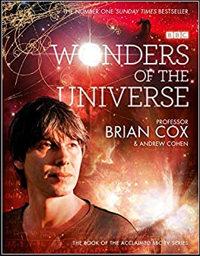
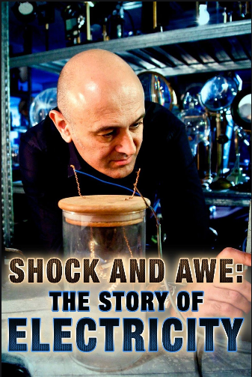 | 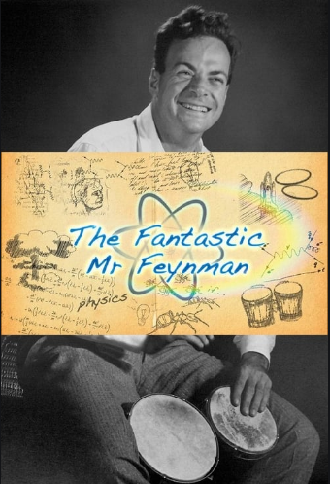

TED Talks

The search for dark matter – and what we’ve found so far | Roughly 85 percent of mass in the universe is "dark matter" -- mysterious material that can't be directly observed but has an immense influence on the cosmos. What exactly is this strange stuff, and what does it have to do with our existence? Astrophysicist Risa Wechsler explores why dark matter may be the key to understanding how the universe formed -- and shares how physicists in labs around the world are coming up with creative ways to study it. | 
Have we reached the end of physics? | Why is there something rather than nothing? Why does so much interesting stuff exist in the universe? Particle physicist Harry Cliff works on the Large Hadron Collider at CERN, and he has some potentially bad news for people who seek answers to these questions. Despite the best efforts of scientists (and the help of the biggest machine on the planet), we may never be able to explain all the weird features of nature. Is this the end of physics? Learn more in this fascinating talk about the latest research into the secret structure of the universe. | 
CERN’s supercollider | "Rock-star physicist" Brian Cox talks about his work on the Large Hadron Collider at CERN. Discussing the biggest of big science in an engaging, accessible way, Cox brings us along on a tour of the massive project | 
Is out universe the only universe? | Is there more than one universe? In this visually rich, action-packed talk, Brian Greene shows how the unanswered questions of physics (starting with a big one: What caused the Big Bang?) have led to the theory that our own universe is just one of many in the "multiverse." | 

Research Activities

Research, reading and note making are essential skills for A level Physics study. For the following tasks you are going to produce ‘Cornell Notes’ to summarise your reading.

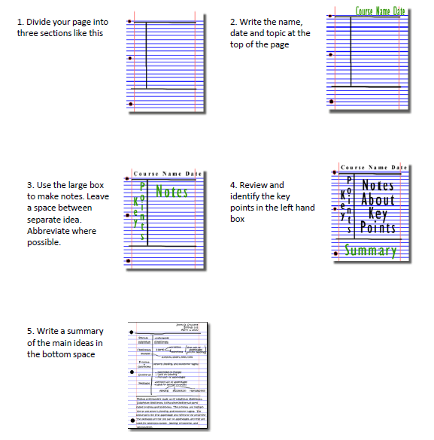

Research Activities

To get the best grades in A Level Physics you will have to get good at completing independent research and making your own notes on difficult topics. Below are links to 5 websites that cover some interesting Physics topics.
Using the Cornell notes system, make 1 page of notes from each site covering a topic of your choice.
http://home.cern/about  CERN encompasses the Large Hadron Collider (LHC) and is the largest collaborative science experiment ever undertaken.  Find out about it here and make a page of suitable notes on the accelerator. | 
http://joshworth.com/dev/pixelspace/pixelspace_solarsystem.html  The solar system is massive and its scale is hard to comprehend. Have a look at this award-winning website and make a page of suitable notes. | 
https://phet.colorado.edu/en/simulations/category/html  PhET create online Physics simulations when you can complete some simple experiments online. Open up the resistance of a wire html5 simulation. Conduct a simple experiment and make a one page summary of the experiment and your findings. | 
http://climate.nasa.gov/  NASA’s Jet Propulsion Laboratory has lots of information on Climate Change and Engineering Solutions to combat it. Have a look and make notes on an article of your choice. | 
http://www.livescience.com/46558-laws-of-motion.html  Newton’s Laws of Motion are fundamental laws for the motion of all the object we can see around us. Use this website and the suggested further reading links on the webpage to make your own 1 page of notes on the topics. | 

Getting ready to study…..

A level Physics will use your knowledge from GCSE and build on this to help you understand new and more demanding ideas. Complete the following tasks to make sure your knowledge is up to date and you are ready to start studying.
Standard Form

At A level quantity will be written in standard form, and it is expected that your answers will be too.

This means answers should be written as ….x 10y. E.g. for an answer of 1200kg we would write 1.2 x 103kg. For more information visit:

www.bbc.co.uk/education/guides/zc2hsbk/revision

1. Write 2530 in standard form.

2. Write 280 in standard form.

3. Write 0.77 in standard form.

4. Write 0.0091 in standard form.

5. Write 1 872 000 in standard form.

6. Write 12.2 in standard form.

7. Write 2.4 x 10² as a normal number.

8. Write 3.505 x 10¹ as a normal number.

9. Write 8.31 x 10⁶ as a normal number.

10. Write 6.002 x 10² as a normal number.

11. Write 1.5 x 10⁻⁴ as a normal number.

12. Write 4.3 x 10³ as a normal number.

Rearranging formulae

This is something you will have done at GCSE and it is crucial you master it for success at A level.

For a recap of GCSE watch the following links:
- www.khanacademy.org/math/algebra/one-variable-linear-equations/old-school-equations/v/solving-for-a-variable
- www.youtube.com/watch?v=_WWgc3ABSj4

1. E=m x g x h to find h

2. Q= I x t to find I

3. E = ½ m v² to find m

4. E = ½ m v² to find v

5. v = u + at to find u

6. v = u + at to find a

7. v² = u² +2as to find s

8. v² = u² +2as to find u

Atomic Structure

You will study nuclear decay in more detail at A level covering the topics of radioactivity and particle physics. In order to explain what happens you need to have a good understanding of the model of the atom. You need to know what the atom is made up of, relative charges and masses and how sub atomic particles are arranged.

The following video explains how the current model was discovered www.youtube.com/watch?v=wzALbzTdnc8

Describe the model used for the structure of an atom including details of the individual particles that make up an atom and the relative charges and masses of these particles. You may wish to include a diagram and explain how this model was discovered by Rutherford

Significant figures

At A level you will be expected to use an appropriate number of significant figures in your answers. The number of significant figures you should use is the same as the number of significant figures in the data you are given. You can never be more precise than the data you are given so if that is given to 3 significant your answer should be too. E.g. Distance = 8.24m, time = 1.23s therefore speed = 6.75m/s

The website below summarises the rules and how to round correctly.
http://www.purplemath.com/modules/rounding2.htm

Give the following to 3 significant figures:
1. 3.4527
2. 40.691
3. 0.838991
4. 1.0247
5. 59.972

Calculate the following to a suitable number of significant figures:
6. 63.2/78.1
7. 39+78+120
8. (3.4+3.7+3.2)/3
9. 0.0256 x 0.129
10. 592.3/0.1772


Social Media

Suggestions of people to follow on Twitter:

- The most interesting way to learn physics online
@ALevelPhysicsHQ

- News, views and information for the global physics community
@PhysicsWorld

- Dedicated to physics and astronomy lovers
@ZonePhysics

- The Institute of Physics is a leading scientific membership society working to advance physics for the benefit of all
@PhysicsNews

- Physics Today is the world’s most popular physics magazine
@PhysicsToday

- A journal for cutting-edge physics research
@NaturePhysics


Keeping it Fresh……..

It is important to keep the knowledge you have gained at GCSE fresh in your mind ready to start your A levels in September.
Why not spend some time looking over some past papers and using the mark schemes to assess how well you’ve done.

Physics GCSE Units 1 and 2 – Past Papers and Marking Schemes:
https://www.wjec.co.uk/qualifications/qualification-resources.html?subject=Physics&level=gcsefrom2016&pastpaper=true

Science Double Award GCSE Units 3 and 6 – Past Papers and marking Schemes:
https://www.wjec.co.uk/qualifications/qualification-resources.html?subject=sciencedoubleAward&level=gcsefrom2016&pastpaper=true

Planning Ahead…….

In order to prepare yourself for further study, have a look at the resources below:
WJEC Specification – GCE AS/A Level in Physics | https://www.wjec.co.uk/qualifications/science/as-a-level/physics-as-a-level-2015/wjec-gce-physics-spec-from-2015-english.pdf
WJEC Specimen Assessment Materials | https://www.wjec.co.uk/qualifications/science/as-a-level/physics-as-a-level-2015/wjec-gce-physics-sams-from-2015.pdf
WJEC Past Papers and Marking Schemes | https://www.wjec.co.uk/qualifications/qualification-resources.html?subject=Physics&level=gceAsafrom2015&pastpaper=true
WJEC AS/A Level Physics Lab Book | https://www.wjec.co.uk/qualifications/science/as-a-level/physics-as-a-level-2015/Physics%20lab%20book%20English.pdf
Revision Guide – Units 1 and 2 | https://resources.wjec.co.uk/Pages/ResourceSingle.aspx?rIid=2955
Revision Guide – Unit 3 | https://resources.wjec.co.uk/Pages/ResourceSingle.aspx?rIid=2737
Revision Guide – Unit 4 | https://resources.wjec.co.uk/Pages/ResourceSingle.aspx?rIid=2770

