The Use of the A-level Mindset (VESPA) Programme at Post-16

In 2020, the sixth form team at St Julian’s School were introduced to the VESPA programme after attending seminars with authors Martin Griffin and Steve Oakes. The programme examines the characteristics of the A Level mindset, which can be used to enhance our tutorial programme for years 12 and 13.
Martin Griffin and Steve Oakes developed the VESPA system after seeing some students in their sixth forms make giant strides between 16 and 18, leaping up from pretty modest GCSE results to achieve outstanding results in year 13, whilst for some others it was the reverse. Griffin and Oakes set about researching the factors behind their observations and from their own work with students, together with lots of other educational research, they developed the VESPA programme.
The VESPA programme identifies five elements of the mindset; vision, effort, systems, practice and attitude, are at the heart of non-cognitive development, and provides a large number of twenty-minute tutorial/intervention or coaching activities designed to slowly deliver change in student behaviours.
As a sixth form, we have always placed a great importance on our tutorial programme, and I have no doubt that the VESPA programme will make a positive impact upon the progress of our students.
It is important that our students understand what is required of them and how to achieve their potential. The VESPA programme identified the characteristics of students who achieve and exceed their target grades and in turn introduces and coaches the following qualities within our students:
- Vision: they know what they want to achieve.
- Effort: they work hard and put in many hours of proactive independent study.
- Systems: they organise their learning resources over time.
- Practice: they practice and develop their skills
- Attitude: they respond constructively to setbacks.
We are very proud of the progress we have made, particularly within the sixth form, however it is important for us to realise that learning and development is a process that is continually evolving and we are a modern, aspirational and innovative school.
It is essential that staff, students and parents are aware of the tutorial activities we are employing to specifically target these skills/qualities. We are proud of our learners and want to equip them with the knowledge and understanding to make a difference in our world.
Examples of activities the students have undertaken include;
- The 21st birthday activity – This was a great exercise to get students to develop their vision of what they wanted to achieve at sixth form. Students were asked to picture an unusual 21st birthday at which their family and friends stand up and describe the type of person they are. They were asked to think about the following questions.
- What would you like your friends to say about you? What qualities would you like them to admire in you?
- How would you like to be described by your friends and family?
- When they list your achievements so far, what do you want them to be?
- When they describe all the things you are still going to do, and the hopes they have for your future, what will they say?
We found this a really simple but yet powerful activity in getting students to reflect on their motivation for being at sixth form and what they would like to achieve.
- Another activity we found very useful in our sessions was the ‘1-10 Scale’. In this we got students to initially reflect on and score their level of effort in the autumn term.
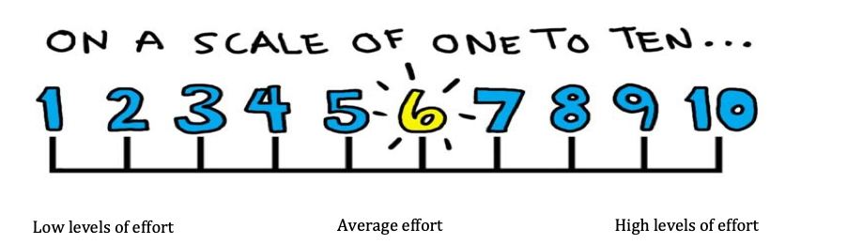
We then explained to students that the problem with making a judgement about your own levels of effort is that scales can be subjective and that to make this meaningful we needed to put some concrete figures based on research to quantify effort. Research shows that AS-level students who end up with three A grades tend to do 20 hours of independent study per week. At A-level, top students (those aiming for three A’s or A*s) do about 30 hours of independent study per week. Students then were asked to reassess their effort score using the following chart. This really made our students reflect on whether they were putting in the right amount of effort and again we found this a really simple and powerful activity in tutorial time.
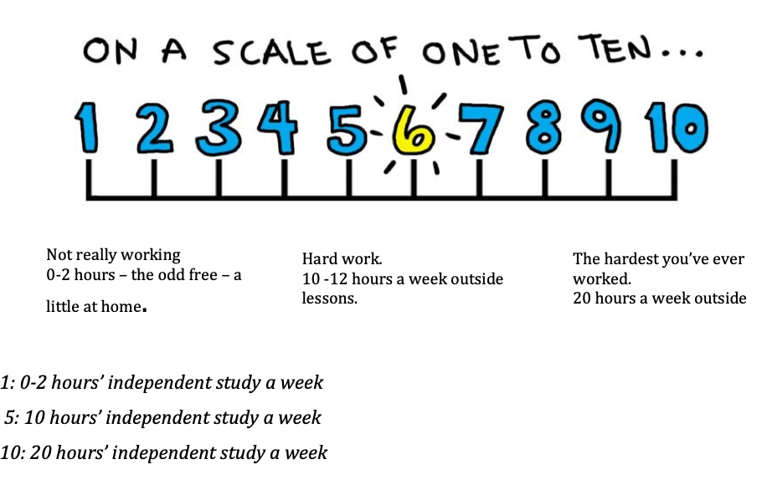Finally, a third exercise which our students really benefitted from was the ‘Three Types of Attention’ Activity. This was designed to help students to develop their systems/organisational skills and involved them breaking down tasks they needed to complete into one of three categories.
The idea behind the activity is that everyone’s day moves through phases, for example there are times when you’re fired up and raring to go, there are times when your energy levels are just average and there are times when you feel your attention is low and your motivation dips.
Students began breaking down tasks into those which they could complete when they were fully focussed and fired up (Proactive Attention), those they could complete when they were just ticking along nicely (Active Attention) and those they could complete effectively even if they were tired or flagging (Inactive Attention). Lots of our students found this incredibly useful as it not only got them to list what they needed to do, it also helped them to organise their time effectively and boosted productivity.


