AS Level Art and Design

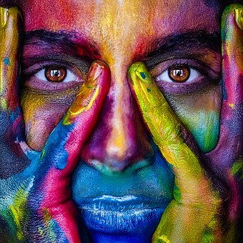

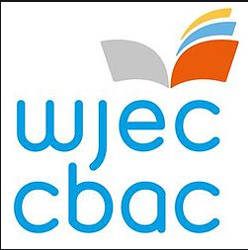
Using your GCSE knowledge and skills ……..

It is important to keep the knowledge and skills you have gained at GCSE fresh in your mind ready to start your A levels in September. The AS level course has similar Learning Outcomes as the GCSE.
AO1: Develop ideas through sustained and focused investigations informed by
contextual and other sources, demonstrating analytical and critical understanding.

AO2: Explore and select appropriate resources, media, materials, techniques and
processes, reviewing and refining ideas as work develops.

AO3: Record ideas, observations and insights relevant to intentions, reflecting critically
on work and progress.

AO4: Present a personal and meaningful response that realises intentions and, where
appropriate, makes connections between visual and other elements.

Look back over your GCSE work. How did you develop the skills linked to each assessment objective? Where are your strengths and areas of weakness?

The A Level course….
The course is 100% coursework. You will have a choice of how you specialize in fine art, Photography, textiles, 3D Design, Graphic communication, critical and contextual studies, or art, craft and design.

Year 12
UNIT 1: Personal Creative Enquiry.
In this unit you will develop your coursework portfolio through your own chosen theme. You will look at the work of a wide range of artists and study their work or techniques. You will build upon and explore skills in drawing, painting, printmaking, textiles, ICT, photography and mixed media.

Year 13
UNIT 2: You will develop your coursework portfolio through your own chosen theme. This will be accompanied by a short essay.
UNIT 3: In the Spring term of year 13 you will be given the exam paper, where you will select a question to create a portfolio on, the will produce a final piece during a 15hr exam which will be taken in April/May.

Planning Ahead…….

In order to prepare yourself for further study, have a look at the specification from WJEC below:
AS Level examination specification | https://www.wjec.co.uk/media/4b5ftor0/wjec-gce-art-and-design-spec-from-2015-e.pdf

Useful links…..
Drawing predates the written language which in itself is a form of mark making. Drawing and mark making is at the root of all visual communication. Through this practice we are able to organise the world visually and to see and understand.
Why is Drawing Important? https://www.youtube.com/watch?v=NEIiUs7eg7c
Why We Should Draw More (and Photograph Less) https://www.youtube.com/watch?v=k1eHm0PNnjo
Matisse https://www.youtube.com/watch?v=t4Fc0NbX51s
Picasso https://www.youtube.com/watch?v=X59U4mUqWtw
Watch Alberto Giacometti draw! https://www.youtube.com/watch?v=QS0PzOwfmHo
George Condo Interview: The Way I Think https://www.youtube.com/watch?v=BhRdlVcQnjk
Michael Craig-Martin's "Drawings": Installation Timelapse https://www.youtube.com/watch?v=eaAf61yF8gE
Contemporary Drawing https://www.youtube.com/watch?v=KaSmuAPJ9Iw
Drawing Is Coming Back In A Big Way https://www.youtube.com/watch?v=fd5ObM-QKfM
Artist Draws With One Line https://www.youtube.com/watch?v=8Z38jh2eeIU
Mr Doodle https://www.youtube.com/watch?v=1UgQsaC9c6A
Artist Spends Hours Creating One 6-Second Video https://www.youtube.com/watch?v=aNpRneyS_mI

Online Museums

Google Arts & Culture: Virtual Museums
Online Tours: The Louvre
The Museum of the World
Guggenheim Online Collection
Moma Learning

Getting ready to study…..
Completing the following activity will help prepare you for studying A Level Art in September:
Task 1
Create a handmade Sketchbook with at least 12 pages. Investigate how to make your own by looking on Youtube or Pinterest.

In this sketchbook, research into 2 artists or art movements/styles from the grids below. For each one, take a page of your sketchbook. For each artist/style/genre include:
- Information about the art movement/artist from a historical viewpoint. Why did the movement start? Who were the main artist involved? What does the work visually look like?
- Information about the way the artwork was made e.g. media. Describe the techniques and materials used.
- Information based on what you think of the work, your own opinions.
- Examples of an artists work
Be as creative as possible with how you display this information Use a combination of drawings, paintings, and text/words to illustrate your artist research, using a range of appropriate materials, techniques and processes.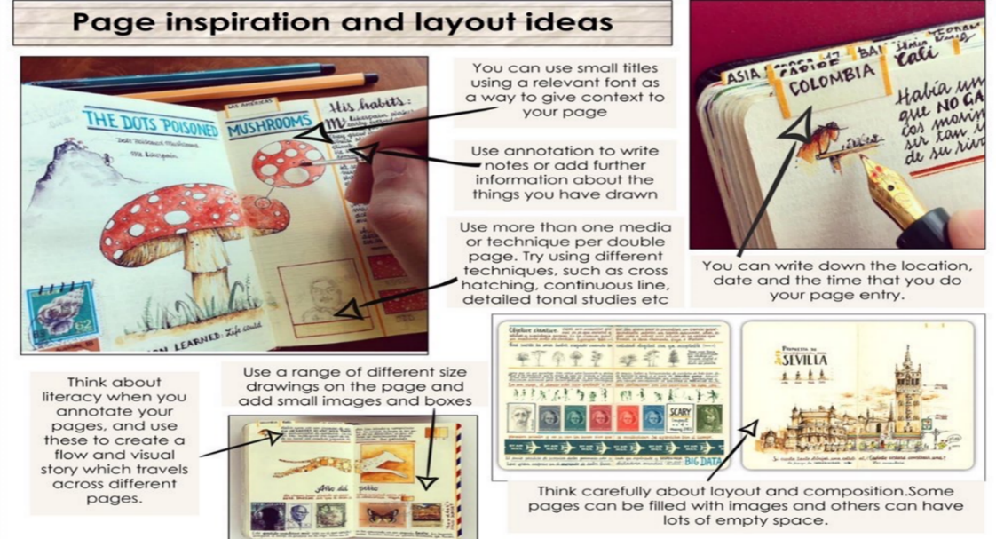

Landscape | Culture/  Pattern | Nature | Photography | Street/Urban Art
Kyffin Williams | Polynesian | Angie Lewin | Howard Schatz (in character) | Banksy
Monet | Adinkra | Richard Shilling | Muybridge | Roadsworth
Alexis Snell | Aboriginal | Andy Goldsworthy | David Hockney (Joiners) | The Boyle Family
L.S. Lowry | Maori | Georgia Okeeffe | Dianne Arbus | Slinkachu
The Boyle Family | Tribal | William Morris | Daniel Kukla | Invader
David Hockney | Tjapaltjarri | Henri Rousseau | Man Ray | Ben Wilson (gum)
Mondrian | Arabic | Richard Long | Jerry Uelsmann | J. M. Basquiat
Van Gogh | Egyptian | Eugene Seguy | Light Drawing | Ian Cook
Edward Hopper | N.A. Indian | Michael Mew | John Stezaker | Mark Jenkins (sellotape)
Victor Enrich | Sonia Delauney | Ernst Haeckel | Cyanotype/Photogram | Phillipa Lawrence
Fauvism | M.C. Escher | Lorenzo Duran | Levitation Photography | Julianna Santacruz Herrera
Turner | Zentangles | Jason Scarpace | Aperture/Shutter speed | Raubdruckerin

Sculpture | Fashion | Figure | Image & Text | Still Life
Barbara Hepworth | Mary Quant(60`sOpArt) | Gustav Klimt | Dada | Cezanne
Henry Moore | Vivien Westwood (Punk) | Edward Hopper | Isaac Salazar | Vanitas
Claes Oldenburg | Alexander McQueen | Picasso | Barbara Kruger | Morandi
Anthony Gormley | Philip Traecy | Modigliani | Wes Wilson | Dennis Wojtkiewrcz
Anish Kapoor | Nicholas Kirkwood | Van Gogh | WWI/WWII Posters | Mat Collishaw
Giacometti | Recycled Fashion | Ilaria Marutti | Propaganda Poster | Cubism
Alexander Calder | Christian Louboutin | Lucian Freud | Robert Ryan | Wayne Thiebaud
Ron Muek | Manolo Blahnik | Derek Gores | Peter Blake | Pieter Claesz
Rachel Whiteread | Piers Atkinson | Michelle Caplan | Billboard Adverts | Lisa Milroy
Anthony Caro | Madeleine Vionnet | Dominik Jasinski | Fiona Banner | Michael Craig Martin
Grayson Perry | Stephen Jones | Egon Schiele | Book Covers | Claes Oldenburg
Joan Miro | Victorian Fashion | Chuck Close | Fiodor Sumkin | Sarah Graham
Picasso |  | Paula Rego | Cecil Touchon | Raymond Logan
Thomas Hill |  | Toulouse Lautrec | Lance Letscher | Margret Morrison

