Contents:
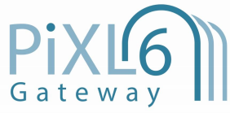PiXL Gateway: Progression - Art
I. What areas of Art & Design can I study?
II. Where should I start?
III. Equipment List
IV. Reading List Tasks
Welcome to A Level Art
Now that you’ve decided to study Art at A Level, you’ll need to do a bit of preparation. This pack contains information regarding the course structure, the summer project, suggested equipment list and websites to prepare you to start your A level in September.
The purpose of studying Art at A Level is to develop knowledge and understanding of: -Specialist vocabulary and artist terminology when analysing or explaining your own and others’ work -Theoretical research of a particular genre style and/or tradition
-In-depth understanding of a variety of media, techniques and processes
-Development of an idea, concept or issue
-Recording ideas and observations related to chosen lines of enquiry
-Communicating a particular meaning, message, idea or feeling
1
What do I have to do in A Level Art?
There are two components of the course- the personal investigation and the externally set assignment. The table below summarises the evidence you will produce for each component:
A Level Components | What will I need to do? | How will I evidence this?
Personal Investigation  (coursework)  60% | -Write a personal study (essay) based on your chosen theme -Create a body of work related to a chosen theme/s  -Create a final piece/s | -A 1000-3000 word essay  -Research on a range of artists and/or designers  -Exploration of a variety of  media, techniques and processes -Development of ideas in  response to chosen  artist/s/theme  -Recording of ideas and  observations
Externally Set Assignment (Exam)  40% | -Create preparatory studies based on the theme  -Create a personal outcome/s in 15 hours of sustained focus | -By creating a body of work based on the theme given. This will include research, ideas, exploration of media,  development of ideas and a final piece/s.

The table below summarises tasks you will need to do to meet each objective:
Development of Ideas | Exploration of Media | Recording &  Reflecting | Personal Response
-Research a range of artists- collect images, make a visual study, include biographical information and analyse their artwork  -Create your own ideas inspired by your chosen artist/s  -Show a clear  development of ideas have they been  manipulated,  transformed and edited throughout the journey | -Explore with a wide variety of media,  techniques and  processes  -Continually review and refine your work  consider the potential and the limitations of the media used | -Take own photographs related to chosen  theme/idea  -Create a range of  observational studies from primary and  secondary sources  -Use annotation to  explain your idea/s and to reflect on your  progress | -A final piece plan to document intentions for final piece and  explanation  -A final piece/s that  realises what you  intended to do

2
What areas of Art & Design can I study?
The table below summarises the different types of design you can study:
Art, Craft & Design | Fine Art | Graphic Communication
This includes the exploration of 2D or 3D design. | This could include painting, drawing, printmaking, mixed media, ceramics, installation, moving image and sculpture. | This could include branding, information graphics, advertising, packaging design, interactive media, multimedia, motion graphics or illustration.
Textile Design | Three-Dimensional Design | Photography
This could include textiles for fine art, fashion or interior, costume design, digital textiles, printed and/or dyed fabrics, wallpaper or installed textiles. | This could include ceramics, sculpture, exhibition design, architectural design, product  design, environmental design, design for theatre, jewellery/body ornament or spatial design. | This could include film, video, digital, photojournalism, moving image, documentary photograph, multimedia or film-based  photography.

Where should I start?
You need to think about the following:
• What subject/ theme are you most passionate about?
• What is it about this subject that is interesting?
• What other avenues could this branch into?
• Will you be able to sustain this theme for a long period of time?
• Can you think of any particular artists that could relate to it?
• Are there any particular styles or techniques that you can explore with?
• Are there any current galleries, exhibitions or events that could be relevant?
• What places, objects or things could you collect or photograph?
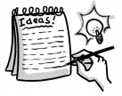
3
Summer Project
Over the holiday, you will need to complete the following tasks:
❑ To select a theme you are passionate about- this could link to people, places, objects, natural world, environment etc.
❑ Visit a gallery or exhibition and document this- photos, drawing, notes, sketches, ticket etc. ❑ To collect images and take photographs related to your theme-whole images, sections, close up etc.
❑ Create a range of drawings and studies from these and life using a range of different materials and techniques-try as many different ones as possible!
❑ Find 2 artists that interest you- it could be their style, use of colour, materials they use etc. Document their work- a copy of their artwork, write some notes to explain it and include biographical information that is relevant.
❑ Create a variety of studies from your sources but now try them in the style of your chosen artists- consider the artists style, technique and use of media etc.
❑ Use notes/annotations to support your work so far- this could include explanations or reflections.
*Document your project in any format you wish- sketchbook, sheets, folder, concertina etc.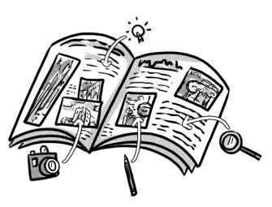
4
Equipment List
Please find below a suggested list of materials for A Level Art:
❑ A1 plastic folder or portfolio
❑ A3 (or bigger) sketchbook
❑ A selection of drawing pencils-(B, 2B, 4B etc.) ❑ Masking tape
❑ Acrylic paint/Oil paint
❑ Watercolour palette or tin
❑ A selection of paintbrushes- (soft and stiff bristle) ❑ Pastels- soft/oil
❑ Soft coloured pencils or watercolour/Aquarelle ❑ Charcoal- compressed or pencil
❑ Selection of inks
❑ Selection of pens- fine liners
❑ Scalpel
❑ A3 cutting mat
❑ Printing ink
❑ Rollers
❑ Plastic mixing tray
❑ Art palette
❑ Selection of paper- cartridge/textured/watercolour
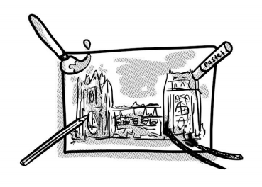5
Suggested Reading
Websites:
https://www.studentartguide.com/
https://www.theartnewspaper.com/
https://www.artforum.com/
http://www.artnews.com/
http://artreport.com/
http://www.tate.org.uk/art/artists/a-z
https://www.artsy.net/artists
https://artuk.org/discover/artists
TED Talks:
https://www.ted.com/talks/alexa_meade?language=en#t-262476 Ted Talk by Alexa Meade- Your body is my canvas
Books:
Thinking About Art: A Thematic Guide to Art History by Peter Huntsman (2015)
What Are You Looking At? 150 Years of Modern Art in the Blink of an Eye by Will Gompertz (2016) Think Like an Artist by Will Gompertz (2015)
Looking at Pictures by Susan Woodford (2018)
The Art Book by Tom Melick (2014)
The Art of Creative Thinking by Rod Judkins (2015)
100 Artists’ Manifestos from the Futurists to the Stuckists by Alex Danchev (2011)
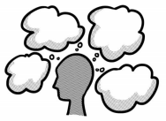
6
Reading List Tasks:
• Collate notes about key subject matter, record quotes and any other relevant information.
• Create a visual mind map of key ideas. Use drawings, images and photographs to illustrate this.
• List key terms and vocabulary- research meanings and/or context. • Write a list of key questions and/or discussions points that are raised.
7

© The PiXL Club Ltd. June 2018
This resource is strictly for the use of member schools for as long as they remain members of The PiXL Club. It may not be copied, sold, or transferred to a third party or used by the school after membership ceases. Until such time it may be freely used within the member school.
All opinions and contributions are those of the authors. The contents of this resource are not connected with, or endorsed by, any other company, organisation or institution.
PiXL Club Ltd endeavour to trace and contact copyright owners. If there are any inadvertent omissions or errors in the acknowledgements or usage, this is unintended and PiXL will remedy these on written notification.

8

