AS Level English Literature

Get ready for literature……….

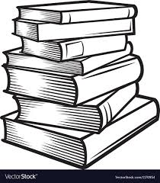

Book Recommendations
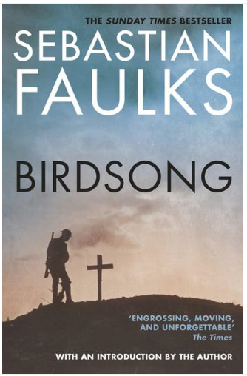
Reading for and beyond the course:
- Arundhati Roy The God of Small Things.
- Anne Tyler Digging to America.
- Khaled Hosseini The Kite Runner.
- Andrea Levy Small Island.
- Ian McEwan Enduring Love.
- Sebastian Faulks Birdsong.
- Mark Haddon The Curious Incident of the Dog in the Night Time.
- Jane Austen Pride and Prejudice
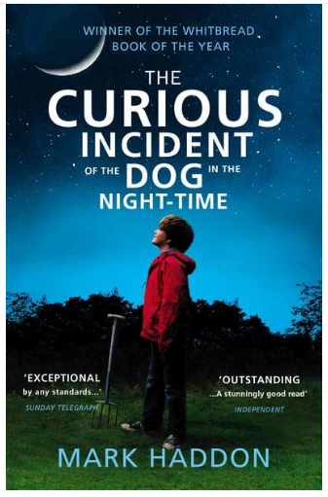
- Charles Dickens Great Expectations
- James Joyce Dubliners
- F Scott Fitzgerald The Great Gatsby
- William Shakespeare Macbeth
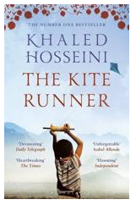
- Christopher Marlowe Dr Faustus
- John Webster The White Devil
- John Milton Paradise Lost Books 1 and 2
- Geoffrey Chaucer The Pardoner’s Tale
- Mary Shelley Frankenstein
- Emily Bronte Wuthering Heights
- Bram Stoker Dracula
- Angela Carter The Bloody Chamber
- Charlotte Bronte Jane Eyre

Poets to read
- Andrew Marvell:
- John Donne
- William Wordsworth
- John Keats
- William Blake
- Alfred Tennyson
- Robert Browning
- Elizabeth Barrett Browning
- Samuel Taylor Coleridge
- Thomas Hardy
- Christina Rossetti
- Dylan Thomas

Set Texts

You will need to check with your teacher to find out which texts you will be studying. You may need your own copies of these texts before starting the A level English Literature course in September.
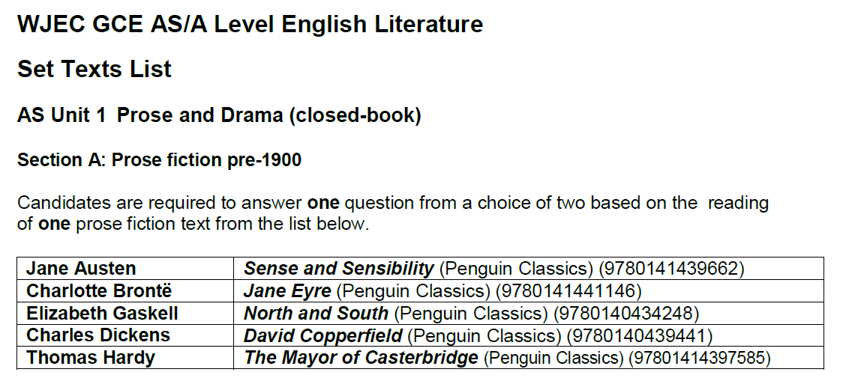
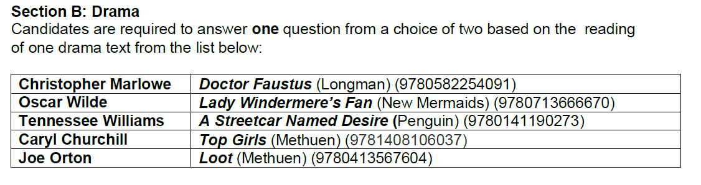
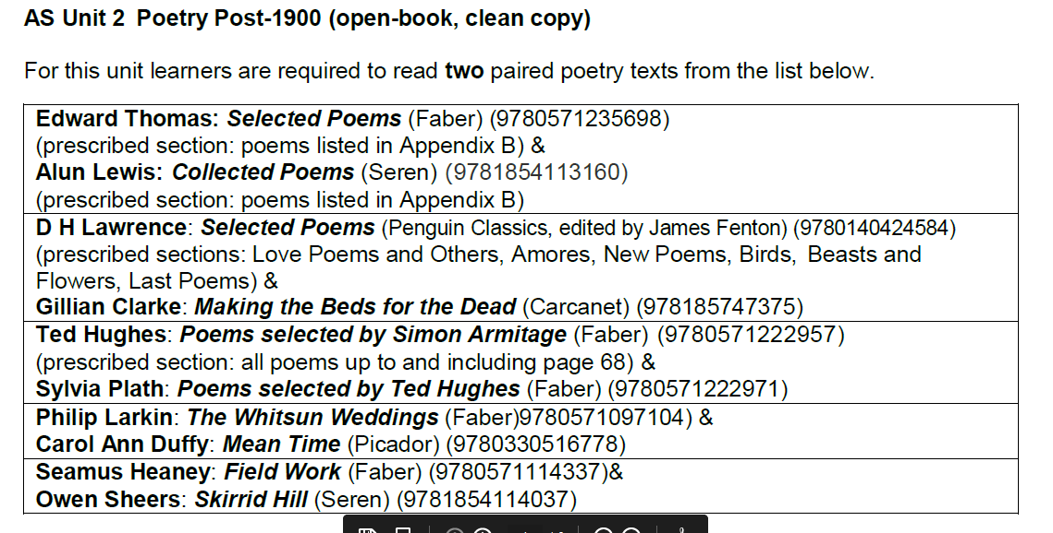

Movie Recommendations
The Miniaturist  Based on: Jessie Burton, The Miniaturist (2014).  This three-part miniseries begins as a familiar story: a young bride is sent off to her mysterious new husband’s creaky, secret-filled home. But instead of finding a closet full of dead women or similar, Nella is given a dollhouse that looks exactly like her new home—filled with figures that look remarkably like those who live there, and whose movements, coordinated by an unseen miniaturist, seem to predict the future. | 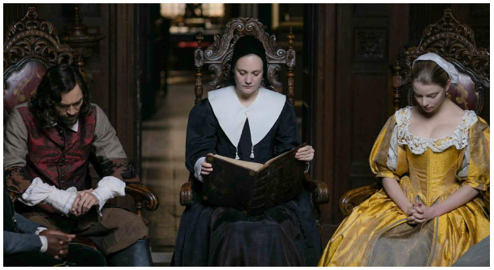
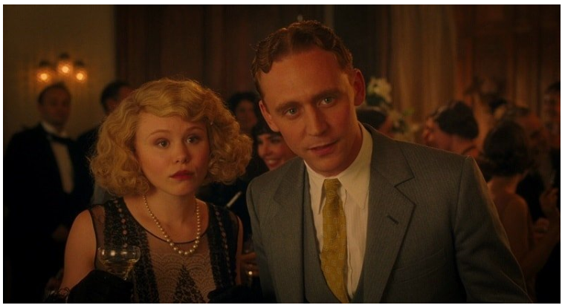 | Midnight in Paris (2011)  A fantastic Woody Allen film, which is literally a nostalgic trip down memory lane, featuring some of the greatest figures of not only literature but also the bygone era. Surprise followed by surprise
Dead Poets Society (1989)  Robin Williams shines as an English teacher who inspires his students through his teaching of poetry. Carpe diem! | 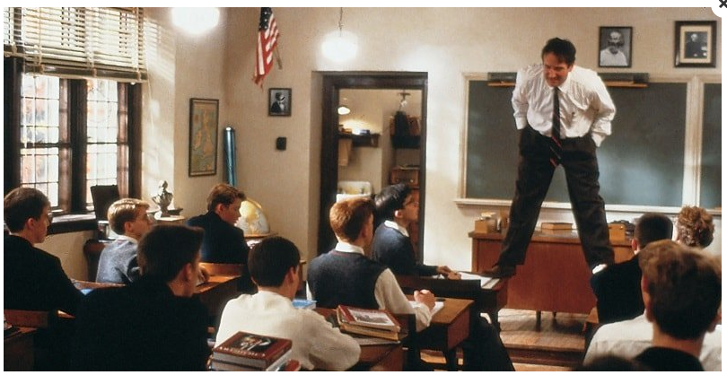
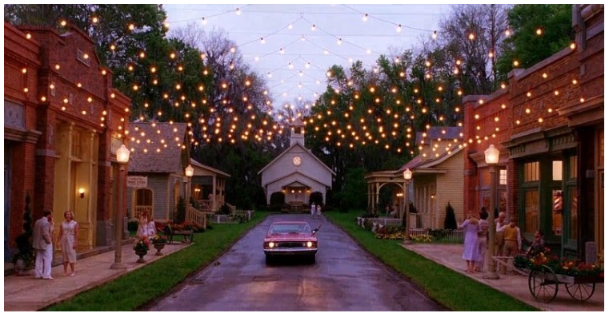 | Big Fish (2003)  Another fantasy film, it beautifully portrays the art of storytelling. It is the enchanting story of a father and son, but it's really the story of stories themselves. Stories are only as great as they are told.
Finding Neverland (2004)  Starring Johnny Depp, the semi-biographical film is about playwright J. M. Barrie and his relationship with a family who inspired him to create Peter Pan. | 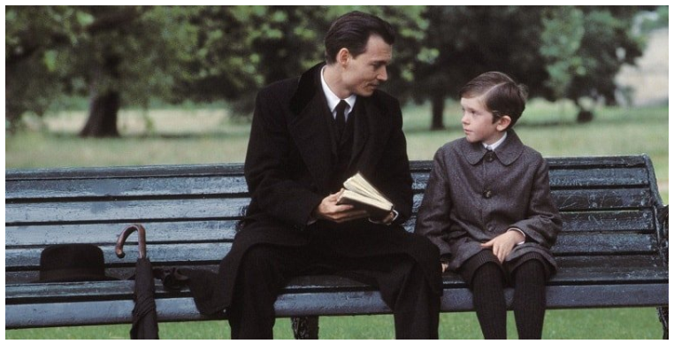
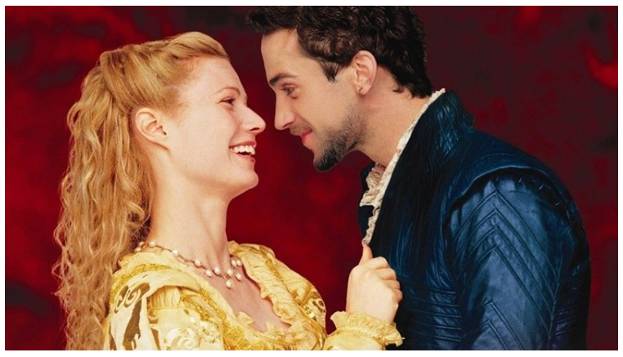 | Shakespeare in Love (1998)  How can we miss anything about the father of literature? The film depicts an imaginary love affair involving Viola de Lesseps and playwright William Shakespeare while he was writing Romeo and Juliet.

TED Talks

The danger of a single story | Our lives, our cultures, are composed of many overlapping stories. Novelist Chimamanda Adichie tells the story of how she found her authentic cultural voice -- and warns that if we hear only a single story about another person or country, we risk a critical misunderstanding. | 
What adults can learn from kids | Child prodigy Adora Svitak says the world needs "childish" thinking: bold ideas, wild creativity and especially optimism. Kids' big dreams deserve high expectations, she says, starting with grownups' willingness to learn from children as much as to teach. | 
3 ways to speak English | Jamila Lyiscott is a “tri-tongued orator;” in her powerful spoken-word essay “Broken English,” she celebrates — and challenges — the three distinct flavors of English she speaks with her friends, in the classroom and with her parents. As she explores the complicated history and present-day identity that each language represents, she unpacks what it means to be “articulate.” | 
Why a good book is a secret door | Childhood is surreal. Why shouldn't children's books be? In this whimsical talk, award-winning author Mac Barnett speaks about writing that escapes the page, art as a doorway to wonder -- and what real kids say to a fictional whale. | 
What reading slowly taught me about writing | Reading slowly -- with her finger running beneath the words, even when she was taught not to -- has led Jacqueline Woodson to a life of writing books to be savored. In a lyrical talk, she invites us to slow down and appreciate stories that take us places we never thought we'd go and introduce us to people we never thought we'd meet. "Isn't that what this is all about -- finding a way, at the end of the day, to not feel alone in this world, and a way to feel like we've changed it before we leave?" she asks. | 

Getting ready to study…..

Completing some of the following activities will help prepare you for studying A Level English Literature in September:
- Read a book from the booklist or by the same author. Create a 10 slide PPT on aspects of the book.
- Record yourself reciting one or more soliloquies from any of Shakespeare’s plays.
- Read a play by a well-known playwright. Write a scene of your own play inspired by what you have read.
- Read some poetry by a poet or from a poetic movement. Annotate one of the poems you have admired most and write one poem of your own as a homage.
- Write a 300-400 word report explaining what three books you would take with you onto a desert island and why.
- Read one book from the booklist or by the same author and write a 300-400 letter to the author saying why you enjoyed it.
- Create a time line of all the different literary movements in literature beginning with the 14th century and ending with modern literature.
- Speak to at least 5 people and record what their favourite piece of children’s fiction and adult literature is and why.
- Create a colourful learning mat with 20 different features to help you in your study of English Literature
- Find a poem that has been written by a poet who is in the literary canon (you may need to begin with finding out what the literary canon is and who is in it!). Bring your chosen poem to our first lesson back – be prepared to tell us why you chose the poem and what you think the poem is about… Happy poem hunting!

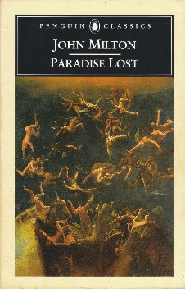
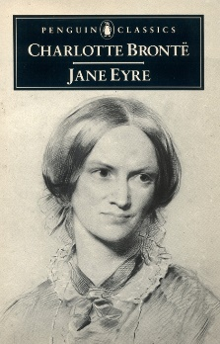
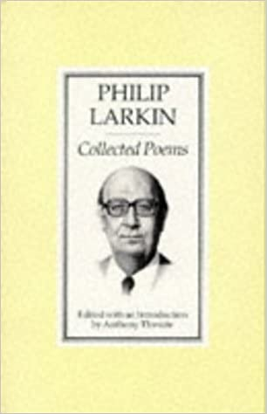
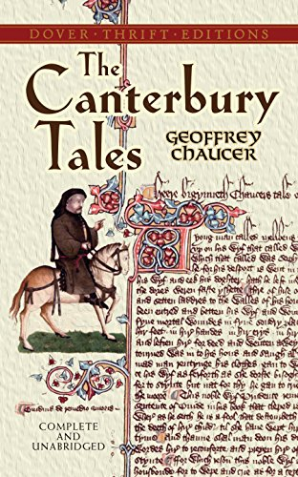
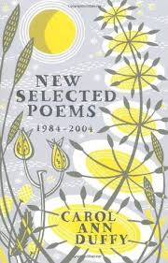
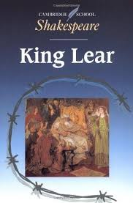
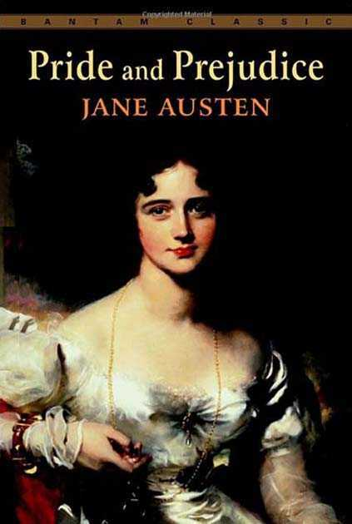
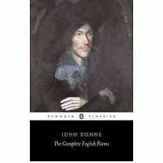
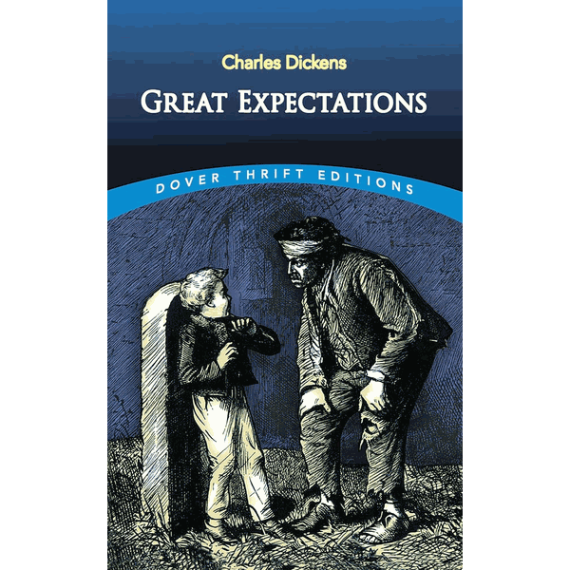
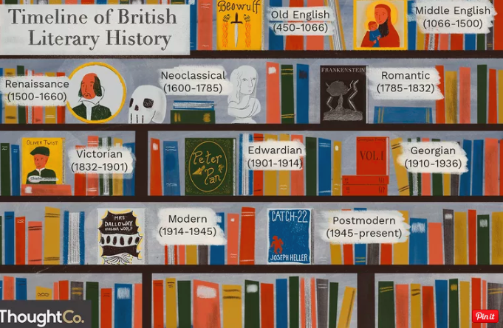
Where would you put the following writers and their works on this timeline?

Tips
- Keep a blog on your reading and what you have found – far easier than carrying around a big file
- Read a couple of the set texts over the summer – remember to be successful you will need to read them a few times before the exams in order to have a really good understanding – If you have not been given this information ask someone in your English department.
- Download electronic copies of your set texts on your device and make notes on it which you can then print
- Download the audio book of the text – listen and read at the same time
- Get an understanding of what Marxism, feminism etc. are and how they help our understanding of literature
- Historical reading of specific periods in history – Victorian period, Renaissance, Romantic period etc.
- Create a profile of an author you will be studying
- Download an app called Pocket (available on Android and Apple devices) – keeps all your reading saved in one place
- Write a weekly reflection of what you have learnt each week – these notes can build up to some great revision notes
- For some useful resources on context ad different interpretations of texts, try The British Library’s ‘Discovering Literature’ site. You can find critics’ views, articles and videos on specific texts and writers as well as overarching themes from different periods from the medieval to the late 20th century.

“There are worse crimes than burning books. One of them is not reading them.” – Ray Bradbury


Social Media

Suggestions of people to follow on Twitter:

- MASSOLIT – short video lectures in the arts, humanities and social sciences for secondary schools
@themassolit

- The English & Media Centre, a not-for-profit trust, providing publications and CPD on English & Media for teacher and students.
@EngMediaCentre

- The British Library
@britishlibrary

- British Council Literature – Connecting British writers with readers and festival audiences internationally.
@LitBritish

- National Centre for Writing - The National Centre for Writing is a place of discovery, exchange, ideas and learning for writers, translators, readers and everyone who loves words.
@WritersCentre

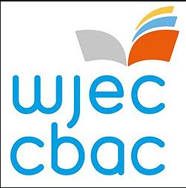
Keeping it Fresh……..

It is important to keep the knowledge you have gained at GCSE fresh in your mind ready to start your A levels in September.
Why not spend some time looking over some past papers and using the mark schemes to assess how well you’ve done.

English Literature GCSE – Past Papers and Marking Schemes:
https://www.wjec.co.uk/en/qualifications/english-literature-gcse/#tab_pastpapers

Planning Ahead…….

In order to prepare yourself for further study, have a look at the resources below:
WJEC Specification – GCE AS/A Level in English Literature | https://www.wjec.co.uk/media/rwdp2iff/wjec-gce-english-lit-spec-from-2015-e-18-12-2019.pdf
WJEC Specimen Assessment Materials | https://www.wjec.co.uk/media/bual13jq/wjec-gce-english-literature-sams-from-2015-e.pdf
WJEC Past Papers and Marking Schemes | https://www.wjec.co.uk/en/qualifications/english-literature-as-a-level/#tab_pastpapers
A level English Literature: Effective writing | https://resources.wjec.co.uk/Pages/ResourceSingle.aspx?rIid=2409
Writing Skills (student focused) | https://resources.wjec.co.uk/Pages/ResourceSingle.aspx?rIid=3055
Analysing unseen text (student focused) | https://resources.wjec.co.uk/Pages/ResourceSingle.aspx?rIid=3054
A level English Literature: Approached to different interpretations | https://resources.wjec.co.uk/Pages/ResourceSingle.aspx?rIid=2433
A level English Literature: Close textual analysis | https://resources.wjec.co.uk/Pages/ResourceSingle.aspx?rIid=2432

