AS Level Biology

A guide to help you prepare yourself for studying AS Level Biology

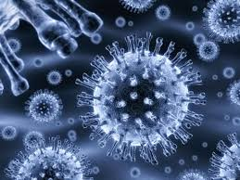

Book Recommendations

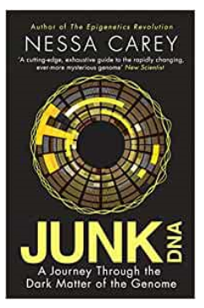 | Junk DNA  Our DNA is so much more complex than you probably realise; this book will really deepen your understanding of the work you will do on Genetics.
A Short History of Nearly Everything  A whistle-stop tour through many aspects of history from the Big Bang to now. This is a really accessible read that will re-familiarise you with common concepts and introduce you to some of the more colourful characters from the history of science! | 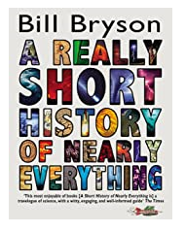
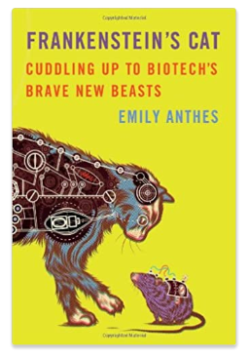 | An easy read..  Frankenstein’s cat  Discover how glow in the dark fish are made and more great Biotechnology breakthroughs.

Movie Recommendations

Here are some films based on real life scientists and discoveries - great watching for a rainy day!

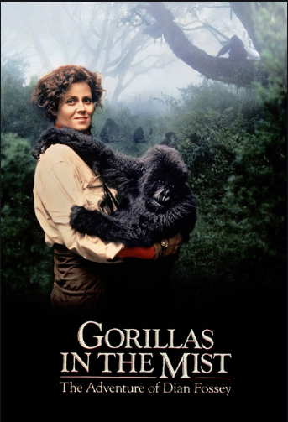 | Gorillas in the Mist (1988)  An absolute classic that retells the true story of the life and work of Dian Fossey and her work studying and protecting mountain gorillas from poachers and habitat loss. A tear jerker.
Something the Lord Made (2004)  Professor Snape (the late great Alan Rickman) in a very different role. The film tells the story of the scientists at the cutting edge of early heart surgery as well as issues surrounding racism at the time. | 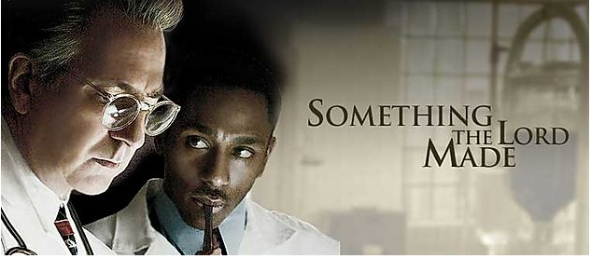
 | Lorenzo’s Oil (1992)  Based on a true story. A young child suffers from an autoimmune disease. The parents research and challenge doctors to develop a new cure for his disease.

TED Talks

How the gut microbes you’re born with affect your lifelong health | Your lifelong health may have been decided the day you were born, says microbiome researcher Henna-Maria Uusitupa. In this fascinating talk, she shows how the gut microbes you acquire during birth and as an infant impact your health into adulthood -- and discusses new microbiome research that could help tackle problems like obesity and diabetes. | 
How a long-forgotten virus could help us solve the antibiotics crisis | Viruses have a bad reputation -- but some of them could one day save your life, says biotech entrepreneur Alexander Belcredi. In this fascinating talk, he introduces us to phages, naturally-occurring viruses that hunt and kill harmful bacteria with deadly precision, and shows how these once-forgotten organisms could provide new hope against the growing threat of antibiotic-resistant superbugs. | 
5 challenges we could solve by designing new proteins | Proteins are remarkable molecular machines: they digest your food, fire your neurons, power your immune system and so much more. What if we could design new ones, with functions never before seen in nature? In this remarkable glimpse of the future, David Baker shares how his team at the Institute for Protein Design is creating entirely new proteins from scratch -- and shows how they could help us tackle five massive challenges facing humanity. | 
Can we cure genetic diseases by rewriting DNA? | In a story of scientific discovery, chemical biologist David R. Liu shares a breakthrough: his lab's development of base editors that can rewrite DNA. This crucial step in genome editing takes the promise of CRISPR to the next level: if CRISPR proteins are molecular scissors, programmed to cut specific DNA sequences, then base editors are pencils, capable of directly rewriting one DNA letter into another. Learn more about how these molecular machines work -- and their potential to treat or even cure genetic diseases. | 

Research Activities

Research, reading and note making are essential skills for A level Biology study. For the following tasks you are going to produce ‘Cornell Notes’ to summarise your reading.

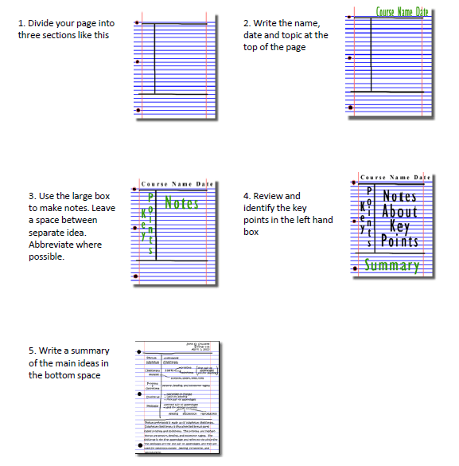

Images taken from http://coe.jmu.edu/learningtoolbox/cornellnotes.html

Research Activities

The Big Picture is an excellent publication from the Wellcome Trust. Along with the magazine, the company produces posters, videos and other resources aimed at students studying for GCSEs and A level.  For each of the following topics, you are going to use the resources to produce one page of Cornell style notes.  Use the links or scan the QR code to take you to the resources. | 
Topic 1: The Cell
Available at: http://bigpictureeducation.com/cell
The cell is the building block of life. Each of us starts from a single cell, a zygote, and grows into a complex organism made of trillions of cells. In this issue, we explore what we know –and what we don’t yet know –about the cells that are the basis of us all and how they reproduce, grow, move, communicate and die.
Topic 2: The Immune System
Available at: http://bigpictureeducation.com/immune
The immune system is what keeps us healthy in spite of the many organisms and substances that can do us harm. In this issue, explore how our bodies are designed to prevent potentially harmful objects from getting inside, and what happens when bacteria, viruses, fungi or other foreign organisms or substances breach these barriers.
Topic 3: Exercise, Energy and Movement
Available at: http://bigpictureeducation.com/exercise-energy-and-movement
All living things move. Whether it’s a plant growing towards the sun, bacteria swimming away from a toxin or you walking home, anything alive must move to survive. For humans though, movement is more than just survival –we move for fun, to compete and to be healthy. In this issue we look at the biological systems that keep us moving and consider some of the psychological, social and ethical aspects of exercise and sport.
Topic 4: Populations
Available at: http://bigpictureeducation.com/populations
What’s the first thing that pops into your mind when you read the word population? Most likely it’s the ever-increasing human population on earth. You’re a member of that population, which is the term for all the members of a single species living together in the same location. The term population isn’t just used to describe humans; it includes other animals, plants and microbes too. In this issue, we learn more about how populations grow, change and move, and why understanding them is so important.
Topic 5: The effect of humans on the earth
Available at: http://bigpictureeducation.com/health-and-climate-change
The Earth’s climate is changing. In fact, it has always been changing. What is different now is the speed of change and the main cause of change –human activities. This issue asks: What are the biggest threats to human health? Who will suffer as the climate changes? What can be done to minimise harm? And how do we cope with uncertainty?

Getting ready to study…..

A level Biology will use your knowledge from GCSE and build on this to help you understand new and more demanding ideas. Complete the following tasks to make sure your knowledge is up to date and you are ready to start studying.
DNA and the Genetic Code

In living organisms nucleic acids (DNA and RNA have important roles and functions related to their properties. The sequence of bases in the DNA molecule determines the structure of proteins, including enzymes.
The double helix and its four bases store the information that is passed from generation to generation. The sequence of the base pairs adenine, thymine, cytosine and guanine tell ribosomes in the cytoplasm how to construct amino acids into polypeptides and produce every characteristic we see. DNA can mutate leading to diseases including cancer and sometimes anomalies in the genetic code are passed from parents to babies in disease such as cystic fibrosis, or can be developed in unborn foetuses such as Downs Syndrome.

Read the information on these websites (you could make more Cornell notes if you wish):
http://www.bbc.co.uk/education/guides/z36mmp3/revision
http://www.s-cool.co.uk/a-level/biology/dna-and-genetic-code

And take a look at these videos:
http://ed.ted.com/lessons/the-twisting-tale-of-dna-judith-hauck
http://ed.ted.com/lessons/where-do-genes-come-from-carl-zimmer

Task:
Produce a poster or PowerPoint presentation using images, keywords and simple explanations to:
- Define gene, chromosome, DNA and base pair
- Describe the structure and function of DNA and RNA
- Explain how DNA is copied in the body
- Outline some of the problems that occur with DNA replication and what the consequences of this might be.

Cells

The cell is a unifying concept in biology, you will come across it many times during your two years of A level study. Prokaryotic and eukaryotic cells can be distinguished on the basis of their structure and ultrastructure. In complex multicellular organisms cells are organised into tissues, tissues into organs and organs into systems. During the cell cycle genetic information is copied and passed to daughter cells. Daughter cells formed during mitosis have identical copies of genes while cells formed during meiosis are not genetically identical.

Read the information on these websites (you could make more Cornell notes if you wish):
http://www.s-cool.co.uk/a-level/biology/cells-and-organelles
http://www.bbc.co.uk/education/guides/zvjycdm/revision

And take a look at these videos:
https://www.youtube.com/watch?v=gcTuQpuJyD8
https://www.youtube.com/watch?v=L0k-enzoeOM
https://www.youtube.com/watch?v=qCLmR9-YY7o

Task:
Produce a one-page revision guide summarising one of the following topics: Cells and Cell Ultrastructure, Prokaryotes and Eukaryotes, or Mitosis and Meiosis.
Whichever topic you choose, your revision guide should include:
- Key words and definitions
- Clearly labelled diagrams
- Short explanations of key ideas or processes.

Biological Molecules

Biological molecules are often polymers and are based on a small number of chemical elements. In living organisms carbohydrates, proteins, lipids, inorganic ions and water all have important roles and functions related to their properties. DNA determines the structure of proteins, including enzymes. Enzymes catalyse the reactions that determine structures and functions from cellular to whole-organism level. Enzymes are proteins with a mechanism of action and other properties determined by their tertiary structure. ATP provides the immediate source of energy for biological processes.

Read the information on these websites (you could make more Cornell notes if you wish):
http://www.s-cool.co.uk/a-level/biology/biological-molecules-and-enzymes
http://www.bbc.co.uk/education/guides/zb739j6/revision

And take a look at these videos:
https://www.youtube.com/watch?v=H8WJ2KENlK0
http://ed.ted.com/lessons/activation-energy-kickstarting-chemical-reactions-vance-kite

Task:
Krabbe disease occurs when a person doesn’t have a certain enzyme in their body. The disease effects the nervous system. Write a letter to a sufferer to explain what an enzyme is.
Your letter should:
- Describe the structure of an enzyme
- Explain what enzymes do inside the body

Exchange and Transport

Organisms need to exchange substances selectively with their environment and this takes place at exchange surfaces. Factors such as size or metabolic rate affect the requirements of organisms and this gives rise to adaptations such as specialised exchange surfaces and mass transport systems. Substances are exchanged by passive or active transport across exchange surfaces. The structure of the plasma membrane enables control of the passage of substances into and out of cells.

Read the information on these websites (you could make more Cornell notes if you wish):
http://www.s-cool.co.uk/a-level/biology/gas-exchange
http://www.s-cool.co.uk/a-level/biology/nutrition-and-digestion/revise-it/human-digestive-system

And take a look at these videos:
http://ed.ted.com/lessons/insights-into-cell-membranes-via-dish-detergent-ethan-perlstein
http://ed.ted.com/lessons/what-do-the-lungs-do-emma-bryce

Task:
Create a poster or PowerPoint presentation. Your work should either compare exchange surfaces in mammals and fish or compare exchange surfaces in the lungs and the intestines. You could use a Venn diagram to do this.

Your poster should:
- Describe diffusion, osmosis and active transport
- Explain why oxygen and glucose need to be absorbed and waste products removed
- Compare and contrast your chosen focus.


Social Media

Suggestions of people to follow on Twitter:

- Commander Chris Hadfield –former resident aboard the International Space Station @cmdrhadfield

- Tiktaalik roseae –a 375 million year old fossil fish with its own Twitter account!
@tiktaalikroseae

- NASA’s Voyager 2 –a satellite launched nearly 40 years ago that is now travelling beyond our Solar System
@NSFVoyager2

- Neil dGrasse Tyson –Director of the Hayden Planetarium in New York
@neiltyson

- Sci Curious –feed from writer and Bethany Brookshire tweeting about good, bad and weird neuroscience
@scicurious

- The SETI Institute –The Search for Extra Terrestrial Intelligence, be the first to know what they find!
@setiinstitute

- Carl Zimmer –Science writer Carl blogs about the life sciences
@carlzimmer

- Phil Plait –tweets about astronomy and bad science
@badastronomer

- Virginia Hughes –science journalist and blogger for National Geographic, keep up to date with neuroscience, genetics and behaviour
@virginiahughes

- Maryn McKenna –science journalist who writes about antibiotic resistance
@marynmck

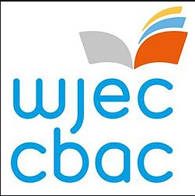
Keeping it Fresh……..

It is important to keep the knowledge you have gained at GCSE fresh in your mind ready to start your A levels in September.
Why not spend some time looking over some past papers and using the mark schemes to assess how well you’ve done.

Biology GCSE Units 1 and 2 – Past Papers and Marking Schemes:
https://www.wjec.co.uk/qualifications/qualification-resources.html?subject=Biology&level=gcsefrom2016&pastpaper=true

Science Double Award GCSE Units 1 and 4 – Past Papers and marking Schemes
https://www.wjec.co.uk/qualifications/qualification-resources.html?subject=sciencedoubleAward&level=gcsefrom2016&pastpaper=true

Planning Ahead…….

In order to prepare yourself for further study, have a look at the resources below:
WJEC Specification – GCE AS/A Level in Biology | https://www.wjec.co.uk/qualifications/science/as-a-level/biology-as-a-level-2015/wjec-gce-biology-spec-from-2015.pdf
WJEC Specimen Assessment Materials | https://www.wjec.co.uk/qualifications/science/as-a-level/biology-as-a-level-2015/wjec-gce-wjec-gce-biology-sams-from-2015.pdf
WJEC Past Papers and Marking Schemes | https://www.wjec.co.uk/qualifications/qualification-resources.html?subject=Biology&level=gceAsafrom2015&pastpaper=true
Revision Booklet – Units 1 and 2 | https://resources.wjec.co.uk/Pages/ResourceSingle.aspx?rIid=2957
Revision Booklet – Unit 3 | https://resources.wjec.co.uk/Pages/ResourceSingle.aspx?rIid=2733
Revision Booklet – Unit 4 | https://resources.wjec.co.uk/Pages/ResourceSingle.aspx?rIid=2772

